1. Write a Python script to add a key to a dictionary

Sample Dictionary: {0: 10, 1: 20}  
Expected Output : {0: 10, 1: 20, 2: 30}

ANSWER:

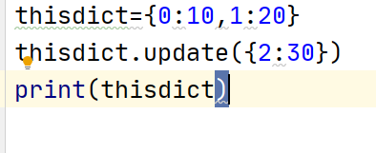

1. Write a Python script to concatenate following dictionaries to create a new one

Sample Dictionary:   
dic1={1:10, 2:20}   
dic2={3:30, 4:40}   
dic3={5:50,6:60}  
Expected Output: {1: 10, 2: 20, 3: 30, 4: 40, 5: 50, 6: 60}

ANSWER:

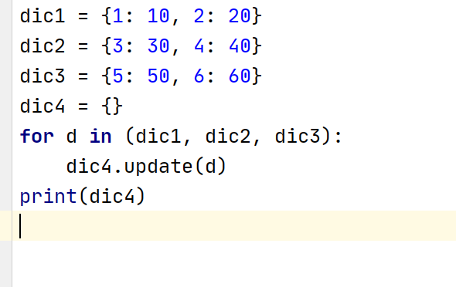

1. Write a Python script to check whether a given key already exists in a dictionary. Obtain key from user input

Sample Dictionary: {1: 10, 2: 20, 3: 30, 4: 40, 5: 50, 6: 60}

Expected Output: “Yes key 5 exists in dictionary” OR “No key 10 does not exists in dictionary”

ANSWER:

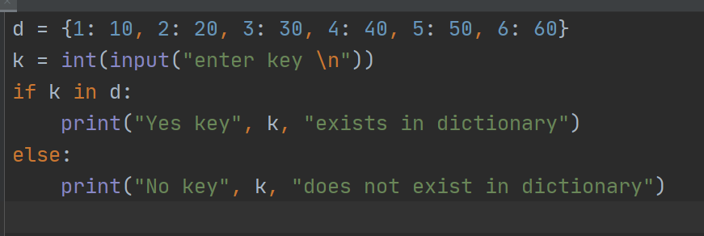

1. Write a Python program to iterate over dictionaries using for loops and print its keys and values separated by a ‘|’ sign

Sample Dictionary: {1: 10, 2: 20, 3: 30, 4: 40, 5: 50, 6: 60}

Expected Output: 1 | 10

2 | 20…

ANSWER:

d = {1: 10, 2: 20, 3: 30, 4: 40, 5: 50, 6: 60}  
for dict_key, dict_value in d.items():  
 print(dict_key, '|', dict_value)

1. Write a Python script to generate and print a dictionary that contains a number (between 1 and n) in the form (x, x*x).   
   Sample Dictionary ( n = 5) :   
   Expected Output : {1: 1, 2: 4, 3: 9, 4: 16, 5: 25}

ANSWER:

num = int(input("Input a number "))  
dict = {}  
for x in range(1, num + 1):  
 dict[x] = x * x  
print(dict)

1. Write a Python script to merge two Python dictionaries

Sample Dictionaries: d1 = {'a': 100, 'b': 200} d2 = {'x': 300, 'y': 200}

Expected Output: {'a': 100, 'b': 200, 'x': 300, 'y': 200}

Answer:

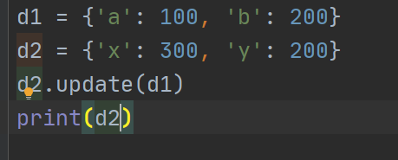

1. Write a Python program to sum all the items in a dictionary

Sample Dictionary: {'data1':100,'data2':-54,'data3':247}

Expected Output: 293

ANSWER:

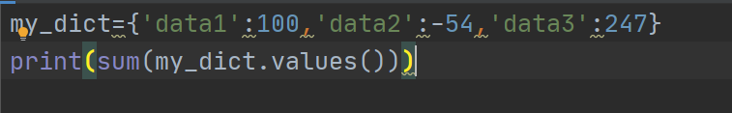

1. Write a Python program to remove a key from a dictionary entered by user input

Sample Dictionary: {'a':1,'b':2,'c':3,'d':4}

Expected Output: {'b': 2, 'c': 3, 'd': 4}

ANSWER:

